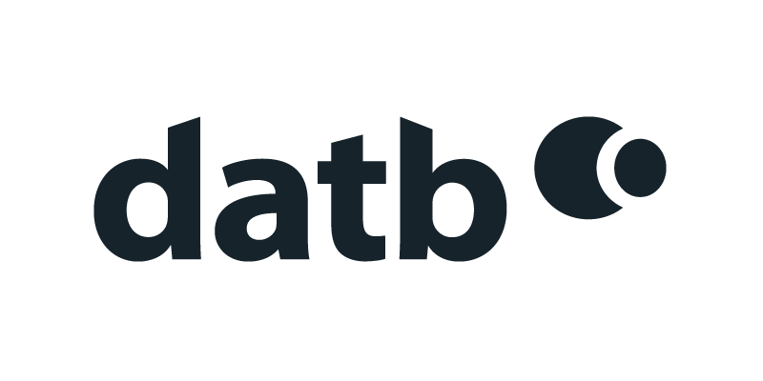
datb – Risk Register
G-Cloud 14 Service Pricing
March 2024

Service Pricing
Services may consist of fixed-price and T&M components.
Rates for T&M work (8 hours exclusive of travel and lunch) are as follows:
 | Strategy & architecture | Business change | Solution development & implementation | Service management | Procurement & management support | Client interface
1. Follow | n/a | n/a | n/a | n/a | n/a | n/a
2. Assist | £650 | £650 | £650 | £650 | £650 | £650
3. Apply | £850 | £850 | £850 | £850 | £850 | £850
4. Enable | £1,050 | £1,050 | £1,050 | £1,050 | £1,050 | £1,050
5. Ensure/Advise | £1,250 | £1,250 | £1,250 | £1,250 | £1,250 | £1,250
6. Initiate/Influence | £1,500 | £1,500 | £1,500 | £1,500 | £1,500 | £1,500
7. Set Strategy/Inspire | £2,000 | £2,000 | £2,000 | £2,000 | £2,000 | £2,000

The annual cost for a production instance is £15,000. This includes hosting, backups, patching, and the annual software licence.
No additional licence charge is made for non-production environments (test, training etc.).
Alternative pricing mechanisms are available where appropriate (for instance for public-facing implementations).

