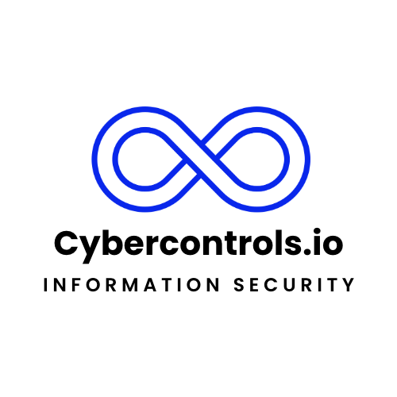
Cybercontrols.io Service Definition Document

Introduction
Cybercontrols.io is an esteemed information security consultancy firm committed to enhancing the cybersecurity posture of organisations across various industries. Specialising in implementation and auditing services, we empower businesses to achieve and maintain compliance with prestigious international standards.

Service Offerings
Cybercontrols.io offers comprehensive consultancy services in the following areas:

- ISO 9001: Quality Management System implementation and auditing to enhance efficiency and product quality.
- ISO 27001: Information Security Management System implementation and auditing to secure information assets.
- ISO 14001: Environmental Management System implementation and auditing for sustainable business practices.
- ISO 45001: Occupational Health and Safety Management System implementation and auditing to ensure workplace safety.
- ISO 22301: Business Continuity Management System implementation and auditing to prepare for disruptive incidents.
- ISO 42001 Artificial Intelligent Management System implementation and auditing to secure information assets.
- SOC 2: Service Organization Control 2 implementation and auditing for managing data based on five "trust service principles."
- Cyber Essentials & Cyber Essentials Plus: Guidance implementation and certification to protect against common cyber threats.

Process Overview
The process for each service typically involves the following stages:

1. Initial Consultation: Understanding client requirements and current compliance status.
2. Gap Analysis: Identifying gaps between current processes and the desired certification requirements.
3. Implementation Planning: Developing a tailored plan for implementing necessary changes and improvements.
4. raining and Development: Providing staff with necessary training on new procedures and protocols.
5. Documentation: Preparing and reviewing all necessary documentation for compliance.
6. Internal Auditing: Conducting thorough internal audits to ensure readiness for official certification audits.
7. Certification Audit: Assisting with the final certification audit conducted by an external body.
8. Continual Improvement: Offering ongoing support to ensure maintenance and continuous improvement of standards.

Quality Assurance
Quality assurance is integral to our services. Cybercontrols.io employs Lead Auditors certified in ISO 9001:2015 and ISO 27001:2022 to oversee all consulting and auditing activities, ensuring the highest service delivery standards.

Deliverables
Each service engagement will result in the delivery of the following:

- A detailed report of the gap analysis.
- A comprehensive implementation plan.
- Official documentation for compliance.
- Training materials and records.
- Internal audit report.
- Support and guidance through the certification audit process.
- A certificate of completion from Cybercontrols.io.

Confidentiality and Security
As a trusted partner, Cybercontrols.io upholds stringent confidentiality and security measures in compliance with ISO 27001:2022 to safeguard all client information.

Contact Information
For inquiries and further information on our services, please contact:

Email: hello@cybercontrols.io

