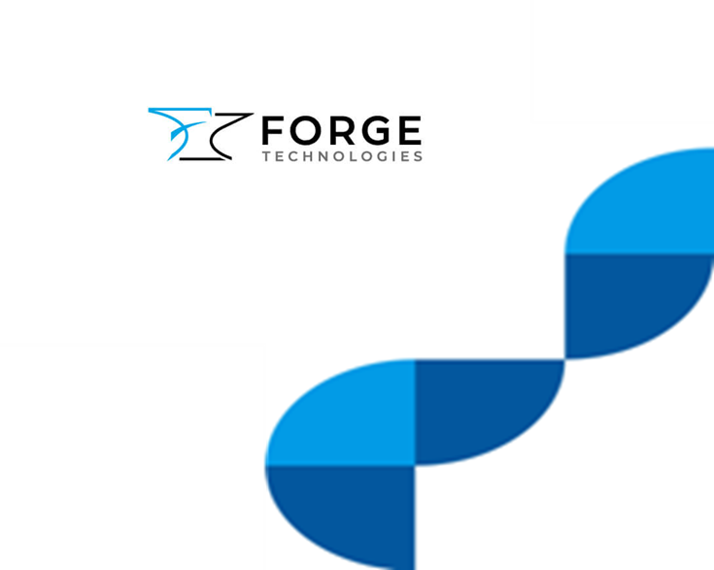

Cloud Deployment Services

Table of Contents
1. Introduction to Forge Cloud Support Services. 2
2. Service Summary 3
3. Service Features 4
4. Service Benefits 4
5. How we engage 5
6. Onboarding 5
7. Delivery Assurance 6
8. Offboarding 6
9. Values 6
10. Pricing Summary 7
10.1. Non-Recuring Services 7
10.2. Recuring Services 7
10.3. Pricing incentives 7
10.4. Trial Options 7
11. Why Forge 8
12. Contact Us 8

Introduction to Forge Cloud Support Services.
Forge delivers a spectrum of cloud services engineered to propel organisations towards cloud excellence swiftly, or to bolster and refine existing cloud frameworks. Our services seamlessly integrate with your team, or we can assume full responsibility for achieving specific outcomes. Such is our confidence in the transformative impact of our collaboration, we offer no-cost trial engagements, allowing you to experience our team's expertise firsthand.
Our methodology in cloud service provision encompasses advisory, deployment, and support & lifecycle services. While these services naturally progress in a cycle, we are equipped to assist customers at any juncture of their cloud journey, mirroring the GCloud framework's flexibility and commitment to public sector excellence.
  Advise  - Discover  - Assess  - Solution & Service Design |   Deploy  - Detailed Design  - Configure & Testing  - Migrate |   Support & Lifecycle  - Manage & Support  - Lifecycle Optimise  - Lifecycle Innovate
The service offerings described in this service definition document relates to Forge’s Cloud Deployment services. Please refer to our other G-Cloud service definitions as required for any other Cloud support services you may require.

Service Summary
Forge Cloud Deployment services are centred around Detailed Design, Configuration & Testing, and Migration services; however, we recognise that each customer engagement is unique, and we therefore tailor our services as required to meet individual needs.
 | Detailed Design  Access a team of technical and project/programme professionals, backed with proven processes, tools and templates. Reduce the time to develop technical/ service designs and project/migration plans that are assured of success. Everything we do is ‘secure by design’ to meet the needs of secure & sensitive organisations
 | Configuration & Testing  We can augment and support your team, or own the complete delivery and testing of your solution. Our expertise not only includes the cloud platforms themselves, but also the associated connectivity, security, and device configurations. Services ranging from Infrastructure as code (IaC) development, through to pre-migration testing.
 | Migration  The key to successful migrations in not just great design, planning, configuration & testing. It’s also about the business engagement, the communication and training plans and operating in an agile fashion plan to overcome challenges. Our migration services provide delivery right through to early life support

Our Cloud Deployment services include service and solution architects, technical engineers and consultants, testing analysts & managers, business analysts, change & communication mangers, trainers and experienced IT project/programme managers. Their expertise span on-premise, hybrid, secure and hyperscale cloud solutions, as well as the networking that interconnects them and the security features that protect them.
Our team includes directly employed employees and trusted associates with whom we have many years of delivery experience. We never assign unknown contractors to any customer engagement. All colleagues have experience of supporting the most secure and sensitive public sector organisations, and have been subject to BS-7858:2019 screening, along with SC or DV clearance
Forge can work alongside your team to deliver a discrete set of standalone services, or act as integrated part of your teams to supplement your skills and capacity. In any scenario we work in a pragmatic fashion, sharing knowledge as we go, and striving to work in your best interests.
Forge will stand behind the outcomes of our deployment services, providing additional guarantees and assurance, should you wish to progress from Forge Cloud ‘Deployment’ to ‘Support & Optimisation’ engagements.

Service Features
- Skilled architects, engineers, consultants, analysts and project/programme managers
- Security cleared and experienced at the highest classification levels
- Deployment services based upon first-hand and operational experience
- Flexible and rapid access to skills
- Innovative commercial engagement options, tailored to suit each customer.
- Knowledge transfer to your team built-in to all engagements
- Assigned resources are supported by the whole Forge team.
- Allocated Service Delivery Manager for each engagement

Service Benefits
- Accelerate your cloud deployment and realise benefits faster
- Reduce deployment costs through incremental skills, experience, and tools
- Flexible and agile access to a range of skills
- Develop best practice designs which assure deployment success
- Outsource/out-task configuring & testing to a proven team
- Ensure technical or service migration is completed and successful.
- Support in recovering projects/migrations that are at risk/stalled
- Incremental support, based upon recent, relevant, and real-world experience
- Solutions to complete the migration of challenging on-prem workloads
- Increase in-house capabilities, by working in collaboration with Forge

How we engage
Every engagement is different, so Forge Cloud Advisory Services are scoped to suit each customer’s individual requirements. The scoping process is led by Forge’s consulting team, which consists of both technical and project consultants with first-hand experience in delivering Cloud transformation programmes. We work in a collaborative fashion to determine the best blend of skills and tooling to achieve your goals
Unlike traditional resourcing providers and many competitors, the Forge consulting team undertake a blend of pre-sales, delivery, and operational support. This unique approach offers a number of benefits such as
- The ability to meet key members of the delivery team prior to commencement
- Continuity of resourcing as your engagement moves from pre-sales scoping into delivery
- Scoping is performed by a team with first-hand and up to date delivery experience
- Detailed and accurate scoping, for improved outcome assurance
- The ability to perform trial engagements
Forge recognise that scoping engagements can be challenging. Many projects will start with a significant number of unknowns. We are therefore happy to shape engagements in a manner that suits you, be that in a highly iterative and agile manner; or working through the complexities to create a detailed plan.
Forge are also able to take a flexible and pragmatic commercial approach to the scoping phase of an engagement. Where possible we do not charge to scope an engagement; however, where further discovery or workshops are required, we can structure the commercials in a way that best suits each engagement. Options include, working at risk, discounted rates, pre-pay/draw-down, or rebate models.
How we ultimately deliver the engagement will be determined by your target outcomes and timelines. Once we have completed the scoping exercise we will create a detailed RACI matrix, tied directly to a Statement of Works, so that every stakeholder has full visibility of what will happen and when. This is accompanied by a RAID (Risk, Assumptions, Issues, Dependencies) log that’s tailored to your specific engagement.

Onboarding
During the scoping engagement a Service Delivery Manager (SDM) will be assigned, and you will have the opportunity to meet with them prior to the delivery phase commencing. The assigned SDM will work hand in hand with the delivery members to ensure structured communications, performance and reporting
In addition to the service delivery manager, Forge consultants from the scoping phase will either transition into delivery roles, or participate in ongoing service reviews. This approach helps ensure continuity of knowledge and that swift adjustments are made during the engagement to achieve the original outcomes.
Forge will work to mobilise all delivery team members as efficiently as possible for each customer engagement. The specific team members will be identified and allocated early in the scoping phase. Any incremental client specific clearances, security briefings, site inductions or training will be completed as early as possible, to ensure that they can ‘hit the ground running’ and deliver value from day-1 of the engagement. Forge will coordinate all mobilisation and on/off-boarding activity to minimise any additional overhead to customer stakeholders.

Delivery Assurance
An SDM will be assigned to all customer engagements, regardless of whether they are fixed scope/outcome or resource augmentation. In any scenario, they will be responsible for day-to-day communications and gathering the performance metrics to include in service reports.
They will also be responsible for ensuring the assigned resources remain an integrated part of Forge, continuing their professional development and working collaboratively with other Forge team members to share best practice, gain feedback/suggestions and obtain additional support.
In addition to the SDM, a member of Forge’s senior leadership team will also play an active role in each customer engagement. This approach ensures that there are no delays in the team receiving any wider support they may need to ensure a successful and high-quality engagement.

Offboarding
At the conclusion of a Cloud deployment engagement, we will conduct thorough transition and handover activities to your in-house team. This typically includes
- Knowledge transfer sessions
- Lessons learned workshop with key stakeholders
- Handover of shared document libraries, including the necessary tools, data/reporting outputs, processes, and training documentation
- End-of-contract review and sign-off against the agreed Scope of Works

Values
Throughout all engagements we will be true to Forge values:
Integrity | Ensuring that every interaction we have, both internal and externally is honest, forthright and respectful. Developing trusted relationships with all parties.
Straight talking | Interactions with clients and within the business are clear and direct. This is integral to building trusted relationships with all parties.
Calibre | Our business is built on the highest calibre of expertise, bringing excellence to all areas of our business.
Accountability | Our culture is built on every person in our business having clear areas of accountability and accepting ownership within their role.
Balance | We operate in a balanced way, respecting our clients’ and colleagues time to create the optimal working environment.
Agility | Business processes are developed in such a way to always ensure we maintain the § to be responsive to client needs
Customer Centric | The customer experience is at the epicentre of every aspect of our business

Pricing Summary
Forge Cloud Deployment Engagements can be structured to provide a fixed set of outcomes, to provide an agreed set of services, or on a time and materials basis. We are open to innovative commercial models, including payments based upon milestones/outcomes, gain-share/pain-share mechanisms, SLAs and service credits.
Services can be commercially structured as a required to suit each customer engagement, options include:

Non-Recuring Services
- As a fixed price project engagement whereby, Forge deliver against an agreed set of outcomes and where we own the delivery risk. Payment is usually against an agreed set of project milestones,
- On a flexible draw down arrangement, against a pool of days that you have bought in advance and hold in credit
- As time and materials using the rate card attached to this service.

Recuring Services
- As a fixed price, fixed term service, whereby Forge deliver against an agree set of requirements. Payment is usually at mutually agreed fixed intervals.
- On a flexible draw-down arrangement against an agreed retainer budget

Pricing incentives
Forge also offer a range of commercial incentives where which reflect the flexibility or commitment made by customers; be that the total value of the contract, the duration, blocks of contiguous days or other factors

Trial Options
Forge offer the ability to trial our Cloud Deployment services. Please contact us to discuss this option.

Why Forge
Forge is a digital IT services business focusing on four technology pillars; Future workplace, Cloud Adoption, Digital Aps & Innovation and Secure Network transformation. We combine the expertise of our subject matter experts with solutions from leading global vendors to deliver robust and assured technology deployments to enterprise clients. Innovation and technical excellence is the foundation of our business.
Unlike the majority of legacy IT providers who have focused on building their own platforms with which to deliver client services (often involving costly development and also introducing design constraints), the Forge strategy is to leverage existing best of breed platforms and to focus on optimising the configuration of these platforms using leading expertise and architects.
Our aim is simple; to design the most flexible, secure and long term solutions, to deploy these solutions and then operate and optimize, ultimately creating and developing robust, long lasting business relationships. Our approach, as you would expect is to focus on understanding business goals of our clients in order to ensure that all technology solutions are aligned.

Contact Us
Forge would love to tell you more about our complete range of Cloud Services. Please contact the team on for a confidential conversation about how we could help.
Email: Sales@forge-technologies.com
Call: 03301748201

