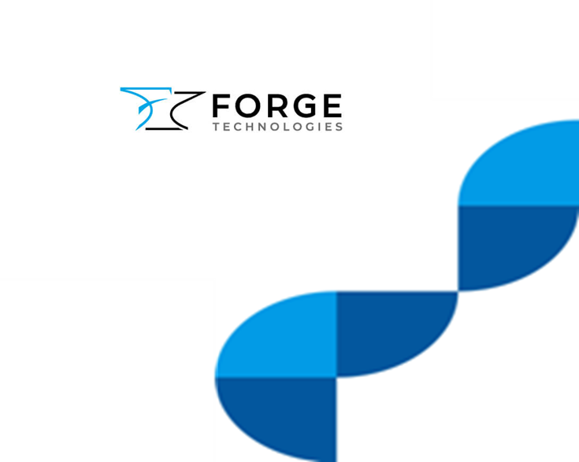

Cloud Resiliency Services

Table of Contents
1. Introduction to Forge Cloud Support Services. 3
2. Service Summary 3
2.1. Service Summary 5
3. Service Features 6
4. Service Benefits 6
5. How we engage 6
6. Onboarding 7
7. Delivery Assurance 8
8. Offboarding 8
9. Values 8
10. Pricing Summary 9
10.1. Non-Recuring Services 9
10.2. Recuring Services 9
10.3. Pricing incentives 9
10.4. Trial Options 9
11. Standard Rate Card 10
11.1. Standards for Consultancy Day Rate Cards 10
11.2. Fixed Price and Recuring Services 10
12. Why Forge 11
13. Contact Us 11

Introduction to Forge Cloud Support Services.
Forge delivers a spectrum of cloud services engineered to propel organisations towards cloud excellence swiftly, or to bolster and refine existing cloud frameworks. Our services seamlessly integrate with your team, or we can assume full responsibility for achieving specific outcomes. Such is our confidence in the transformative impact of our collaboration, we offer no-cost trial engagements, allowing you to experience our team's expertise firsthand.
Our methodology in cloud service provision encompasses advisory, deployment, and support & lifecycle services. While these services naturally progress in a cycle, we are equipped to assist customers at any juncture of their cloud journey, mirroring the GCloud framework's flexibility and commitment to public sector excellence.
Working with Rubrik’s largest and most established MSP, Forge operationalise Rubrik’s Zero Trust Security solutions, delivering data security and protection to customers in over 50 countries worldwide.
The team provides 24/7/365 support to ensure customers can protect, detect and recover critical data and operations with minimal downtime.
MANAGED BACKUP
Forge’s managed service solutions, built on Rubrik’s Security Cloud, enable organisations to control their entire backup environment ensuring resiliency against data loss, natural disasters and cyber attacks.
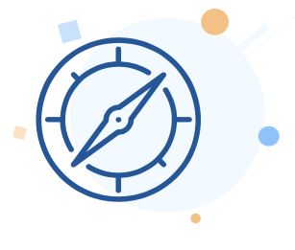  Advise  - Discover  - Assess  - Solution & Service Design | 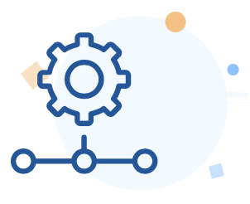  Deploy  - Detailed Design  - Configure & Test  - Migrate |   Support & Lifecycle  - Manage & Support  - Lifecycle Optimise  - Lifecycle Innovate
The service offerings described in this service definition document relates to Forge’s Cloud Resiliency services. Please refer to our other G-Cloud service definitions as required for any other Cloud support services you may require.

Service Summary
Forge Cloud Resiliency services are centred around Backup, Replication, Recovery, and Cyber Resiliency; however, we recognise that each customer engagement is unique, and we therefore tailor our services as required to meet individual needs.
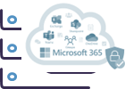 | MANAGED BACKUP  Backup as a Service is an enterprise-grade backup, recovery and archive solution, purpose-built to protect organisations of all sizes, across single or multiple locations in private, public and hybrid cloud environments. Provided as a Rubrik fully managed service including all hardware, software and support, tailored to meet your technical and commercial requirement  M365 MANAGED BACKUP  Keep digital assets safe from harm with OneDrive and SharePoint backup. Suit your business with monthly/annual options and a pay-per-user model. Automate backups for Exchange to maximise speed and manageability. Advanced email archiving, eDiscovery, malware protection and more  OFF-SITE REPLICATION  Replication as a Service provides an up-to-date copy of your backup data in a secure, air-gapped location. Choose one of multiple off-site facilities or an alternative location. In the event of production data loss, this gives you the capability to recover quickly from any point in time, to your chosen location
DISASTER RECOVERY
Disaster Recovery as a Service ensures near-zero recovery times in the event of a significant IT failure. Leverage provided DR platform, removing the need for a secondary data centre. The RecoverView platform enables orchestration and automation of recovery testing and live invocation. This includes a fully-documented audit and compliance report.

CYBER RESILIENCY
Cyber Resiliency as a Service identifies and alerts you to security breaches by automatically monitoring backup data for known threats to discover suspicious activity, ransomware, and cyber attacks. Detect early warning signals of attackers in your environment and accelerate recovery to a last known good state.

Forge services are broadly based around three models: fully-managed, co-managed and self-managed. An example of features is illustrated below; however, this is always tailored around each customers unique requirements. Service models are tailored to take into account the existing and future customer skills/capacity, investments in licences/tooling an information security requirements. Where required, the Forge service design can be profiled to evolve during the term to reflect known changes, for example a planned increase in customer skill/capacity during the first year of service.

Service Summary
Service | Self-managed | Co-managed | Fully-managed
BAU customer admin-access | • Yes | • Yes1 | • No2
3rd line incident support | • Yes | • Yes | • Yes
2nd line incident support | • No | • Optional3 | • Yes
1st line user support | • No | • No | • Optional3
Problem Management | • No7 | • Optional7&3 | • Yes
Response & H/W resolution SLAs | • Yes | • Yes | • Yes
S/W resolution & availability SLAs | • No | • Yes | • Yes
Cloud provider incident management | • Yes | • Yes | • Yes
Cloud provider billing management | • No | • Optional3 | • Optional3
Proactive availability monitoring | • Optional3 | • Yes | • Yes
Change planning support & CAB | • No | • Yes5 | • Yes
BAU change implementation | • No | • Optional4 | • Yes
Non BAU change implementation | • No | • Optional4 | • Yes6
Release management | • No | • Yes | • Yes
Assigned service delivery manager (SDM) | • No | • Yes | • Yes
Service delivery reporting & review | • Yes (Quaterly) | • Yes (monthly) | • Yes (monthly)
Continuous Technology & Service Optimisation planning | • Yes (Quarterly) | • Yes (monthly) | • Yes (monthly)
24x7 Security Operation Centre (SOC) | • No | • Optional3 | • Optional3
On-site engineering support | • Optional3 | • Optional3 | • Optional3

1 = Joint admin access with Forge (subject to joint change process)
2 = Break-glass emergency admin access only
3 = Annual re-occurring charge
4 = Pre-paid credit consumption
5 = Mandatory requirement for joint planning
6 = Chargeable (subject to impact assessment/quote)
7 = Forge will provide support to customers problem investigations; however, the customer will own the problem management process.

Forge can also provide a range of support and optimisation service on an ad-hoc, retained or pre-pay basis. These services include service and solution architects, technical analysts, engineers and consultants, business analysts, change & communication mangers, trainers and experienced IT project/programme and transition managers. Their expertise spans on-premise, hybrid, secure and hyperscale cloud solutions, as well as the networking that interconnects them and the security features that protect them.
Our team includes directly employed employees and trusted associates with whom we have many years of delivery experience. We never assign unknown contractors to any customer engagement. All colleagues have experience of supporting the most secure and sensitive public sector organisations, and have been subject to BS-7858:2019 screening, along with SC or DV clearance
Forge Support & Lifecycle services can provide a discrete set of standalone services, or act as integrated part of your teams to supplement your skills and capacity. In any scenario we work in a pragmatic fashion, sharing knowledge as we go, and striving to work in your best interests.
Forge will stand behind the Service & Optimisation services we provide, providing performance-based Service Level Agreements (SLAs) and Service Credits. During the service design phase, Forge will discuss the key performance indicators and SLAs that matter most to you. These measures will also be can also be changed and evolved as needed to suit your requirements.

Service Features
- Schedule backups that meet your requirements using Rubrik SLA domains.
- Granular recovery of objects across subscriptions.
- Store your backup data in our default location or your own Microsoft Azure storage.
- Perform out-of-place restoration of data with full fidelity and user mapping.
- Quickly locate the specific records you need to restore through keyword search capability.
- Comprehensively review backup and restore details via the Rubrik Security Cloud or history reports.
- Assign roles for administrative specific responsibilities on backup recoveries.
- Gain full visibility of how your backup and restore service is being used

Service Benefits

- Resiliency Against Cyber Threats: Protects against data loss, natural disasters, and cyber attacks.
- Disaster Recovery: Enables quick recovery of IT systems, minimizing downtime.
- Managed Backup: Offers backup, archiving, and recovery in various environments, including on-premises and cloud.
- Off-Site Replication: Ensures operations continue by replicating critical data to a secure location.
- Cyber Resiliency: Provides 24/7 monitoring to prevent data loss and detect cyber threats early.
- Data Security: Protects backup data in an immutable format, on-site, off-site, or in the cloud.
- Anomaly Detection: Uses Machine Learning and AI to detect large data changes or suspicious behavior.
- Quick Recovery: Recovers operations from ransomware and other cyber attacks with near-zero RPOs & RTOs.

How we engage
Every engagement is different, so Forge Cloud Resiliency Services are designed to suit each customer’s individual requirements. The service design scoping process is led by Forge’s services team, which consists of service architects, cloud-ops consultants and ITIL experts. We work in a collaborative fashion to determine the best blend of skills, services and tooling to achieve your goals
Unlike many competitors, the Forge services team undertake a blend pre-sales, delivery, and operational support. This unique approach offers a number of benefits such as
- The ability to meet key members of service team prior to commencement
- Continuity of resourcing as your engagement moves from pre-sales scoping into delivery
- Scoping is performed by a team with first-hand and up to date delivery experience
- Detailed and accurate scoping, for improved outcome assurance
- The ability to perform trial engagements
Forge recognise that designing services for evolving cloud platforms can be challenging. Many service designs will start with a significant number of unknowns. We are therefore happy to work through the process and architect services in a way in a manner that suits you, be that in a pragmatic fashion capturing jointly documented assumptions; or working through the detail to create a tightly defined service design.
Forge are also able to take a flexible and pragmatic commercial approach to the service design phase of an engagement. Where possible we do not charge to create a service design; however, where further discovery or workshops are required, we can structure the commercials in a way that best suits each engagement. Options include, working at risk, discounted rates, pre-pay/draw-down, or rebate models.
How we ultimately design the service will be determined by your cloud platforms, services and architecture, your in-house skills, existing tooling investments, security requirements, operating model, and other factors. Once we have completed the scoping exercise we will create a detailed service design, RACI matrix and transition plan, so that every stakeholder has full visibility of how the service is constructed.

Onboarding
During the service design phase, a transition manager will be assigned, and you will have the opportunity to meet with them prior to the delivery phase commencing. The assigned transition will work hand in hand with the delivery members to ensure structured communications, performance and reporting
In addition to the service delivery manager, Forge consultants from the scoping phase will either transition into delivery roles, or participate in ongoing service reviews. This approach helps ensure continuity of knowledge and that swift adjustments are made during the engagement to achieve the original outcomes.
Forge will work to mobilise all service team members as efficiently as possible for each customer engagement. The specific team members will be identified and allocated early in the scoping phase. Any incremental client specific clearances, security briefings, site inductions or training will be completed as early as possible, to ensure that they can ‘hit the ground running’ and deliver value from day-1 of the engagement. Forge will coordinate all mobilisation and on/off-boarding activity to minimise any additional overhead to customer stakeholders.

Delivery Assurance
An SDM will be assigned to all Cloud Resiliency services. They will be responsible for day-to-day communications and gathering the performance metrics to include in service reports.
They will also be responsible for ensuring the assigned resources remain an integrated part of Forge, continuing their professional development and working collaboratively with other Forge team members to share best practice, gain feedback/suggestions and obtain additional support.
In addition to the SDM, a member of Forge’s senior leadership team will also play an active role in each customer engagement. This approach ensures that there are no delays in the team receiving any wider support they may need to ensure a successful and high-quality engagement.

Offboarding
At the conclusion of a Cloud Resiliency engagement, we will conduct thorough transition and handover activities to your in-house team. This typically includes
- Knowledge transfer sessions
- Lessons learned workshop with key stakeholders
- Handover of shared document libraries, including the necessary tools, data/reporting outputs, processes, and training documentation
- End-of-contract review and sign-off against the agreed Scope of Works

Values
Throughout all engagements we will be true to Forge values:
Integrity | Ensuring that every interaction we have, both internal and externally is honest, forthright and respectful. Developing trusted relationships with all parties.
Straight talking | Interactions with clients and within the business are clear and direct. This is integral to building trusted relationships with all parties.
Calibre | Our business is built on the highest calibre of expertise, bringing excellence to all areas of our business.
Accountability | Our culture is built on every person in our business having clear areas of accountability and accepting ownership within their role.
Balance | We operate in a balanced way, respecting our clients’ and colleagues time to create the optimal working environment.
Agility | Business processes are developed in such a way to always ensure we maintain the § to be responsive to client needs
Customer Centric | The customer experience is at the epicentre of every aspect of our business

Pricing Summary
Forge Cloud Resiliency engagements can be structured to provide a fixed set of outcomes, to provide an agreed set of services, or on a time and materials basis. We are open to innovative commercial models, including payments based upon milestones/outcomes, gain-share/pain-share mechanisms, SLAs and service credits.
Services can be commercially structured as a required to suit each customer engagement, options include:

Non-Recuring Services
- As a fixed price engagement whereby, Forge deliver against an agreed set of outcomes and where we own the delivery risk. Payment is usually against an agreed set of project milestones
- On a flexible draw down arrangement, against a pool of days that you have bought in advance and hold in credit
- As time and materials using the rate card attached to this service.

Recuring Services
- As a fixed price, fixed term service, whereby Forge deliver against an agreed service specification. Payment is usually at mutually agreed fixed intervals.
- As a variable price, fixed term service
- On a flexible draw-down arrangement against a monthly retainer budget

Pricing incentives
Forge offer a range of commercial incentives where which reflect the flexibility or commitment made by customers; be that the total value of the contract, the duration, blocks of contiguous days or other factors

Trial Options
Forge offer the ability to trial our Cloud Resiliency services. Please contact us to discuss this option.

Why Forge
Forge is a digital IT services business focusing on four technology pillars; Future workplace, Cloud Adoption, Digital Aps & Innovation and Secure Network transformation. We combine the expertise of our subject matter experts with solutions from leading global vendors to deliver robust and assured technology deployments to enterprise clients. Innovation and technical excellence is the foundation of our business.
Unlike the majority of legacy IT providers who have focused on building their own platforms with which to deliver client services (often involving costly development and also introducing design constraints), the Forge strategy is to leverage existing best of breed platforms and to focus on optimising the configuration of these platforms using leading expertise and architects.
Our aim is simple; to design the most flexible, secure and long term solutions, to deploy these solutions and then operate and optimize, ultimately creating and developing robust, long lasting business relationships. Our approach, as you would expect is to focus on understanding business goals of our clients in order to ensure that all technology solutions are aligned.

Contact Us
Forge would love to tell you more about our complete range of Cloud Services. Please contact the team on for a confidential conversation about how we could help.
Email: Sales@forge-technologies.com
Call: 03301748201

