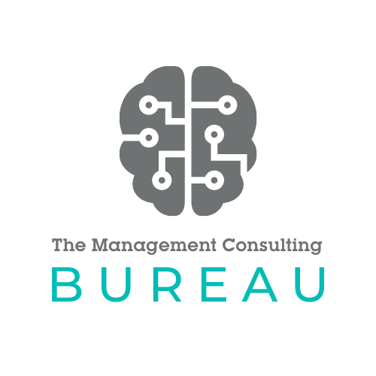

G-Cloud 14: Service Definition
May 2024

Service Definition

ABOUT THE MANAGEMENT CONSULTING BUREAU
We are a boutique consulting firm focused on delivering Transformation in the Public Sector. The team is made up of an experienced group of leaders from both Consulting and Industry. We have a culture of innovation and insight and are focussed on delivering personal outcomes for our clients, turning their plans and vision into a reality.

The Bureau recently completed an important engagement at the Department for Work and Pensions, working with two Director Generals to drive forward a large Transformation Programme. We worked with leadership teams from Digital and Customer Service, as well as the supporting MDTs to plan their Customer Service Transformation, secure Treasury funding and achieve the Programme results.
The Bureau team has deep experience and skills in shaping and delivering transformation programmes within many government departments. We work alongside senior leadership and their multi-disciplinary teams, providing experienced, capable practitioners with deep skills and experience across business analysis, programme management, roadmap and planning, change management, digital transformation, data strategy and customer experience design.
WHAT CLIENTS SAY ABOUT THE BUREAU:
DWP Chief Digital and Information Officer (SIMON MCKINNON)

“The Bureau helped DWP Digital to articulate the technology roadmap for the department, across all our product areas. We were able to use this roadmap to drive conversations across the business as well as engage with external stakeholders including Cabinet Ministers. The Bureau brought to life the digital ambition for DWP, and developed the business case for the DWP Service Transformation funding request to the Government”

DWP DIRECTOR GENERAL, SERVICE EXCELLENCE (AMANDA REYNOLDS)

“The Bureau worked side by side with my Service Transformation team over a 10 month engagement. During this time, The Bureau delivered immediate value by bringing together different parts of the business to define a clear Spending Review bid. Furthermore, The Bureau have set us up for success by defining a new Service Blueprint that will transform how customer interact with DWP in the new digital age”

DWP TRANSFORMATION DIRECTOR (VICTORIA FILKIN)

“The Bureau came alongside my Service Transformation team to architect an ambitious Service Modernisation programme for the whole of DWP. They did this by infusing Industry best practice and Customer Transformation experience.”

WE FOCUS ON 3 AREAS:

SERVICE TRANSFORMATION
For many Government Departments, the reality is that customers are interacting via outdated channels like written mail & contact centres and need to shift these channels to digital. We help you make this shift by architecting the new channel experience (Chat bots, self-service, social and text/whatsapp). We move customers from experiencing moments of misery to moments of magic when interacting with your Department.

DATA STRATEGY
We help you to unlock the power of your data – which for many businesses is sitting on a shelf like a book in a library. Using the latest analytics tools, we mine this data for insight, getting you to a position where, for you, the most important books will be read. So what? This will reduce Department costs, improve taxpayer value and increase customer satisfaction.

BUSINESS CHANGE DELIVERY
Helping to define and deliver the case for change for your business. We work closely with you and your team to roadmap how you deliver change at pace across Digital, Operations and Customer Experience.

OUR SERVICES
The Bureau can support your organisation with the following Cloud Support services:
- Cloud Project, Programme and Portfolio Management Service
- Cloud Change Management Service
- Cloud Business Analysis Service
SERVICE FEATURES
- Strategic planning
- Business case development
- Road map development
- Transformation support
- Business change support
- Data strategy development
- Client capability build
- Operating model design and development
- Implementation planning
- Customer service design

BENEFITS OF ENGAGING WITH THE BUREAU
- Alignment of key stakeholders across the Department e.g. Digital, Finance, Service, Strategy
- Focus on value for money optimisation (VFM)
- Identification and realisation of cloud business benefits and reduction of business costs
- Providing in-depth experience across multiple industries to shape best in class service provision
- Increased delivery success
- Reduced costs
- Financial return on investment
- Speed of execution increased
- Delivery certainty
- Customer satisfaction
- Colleague satisfaction
- Taxpayer benefits
- Risk mitigation
- High performance team

