CoComply Service Definition

IR35 and Worker Classification Services

Dated: May 2024

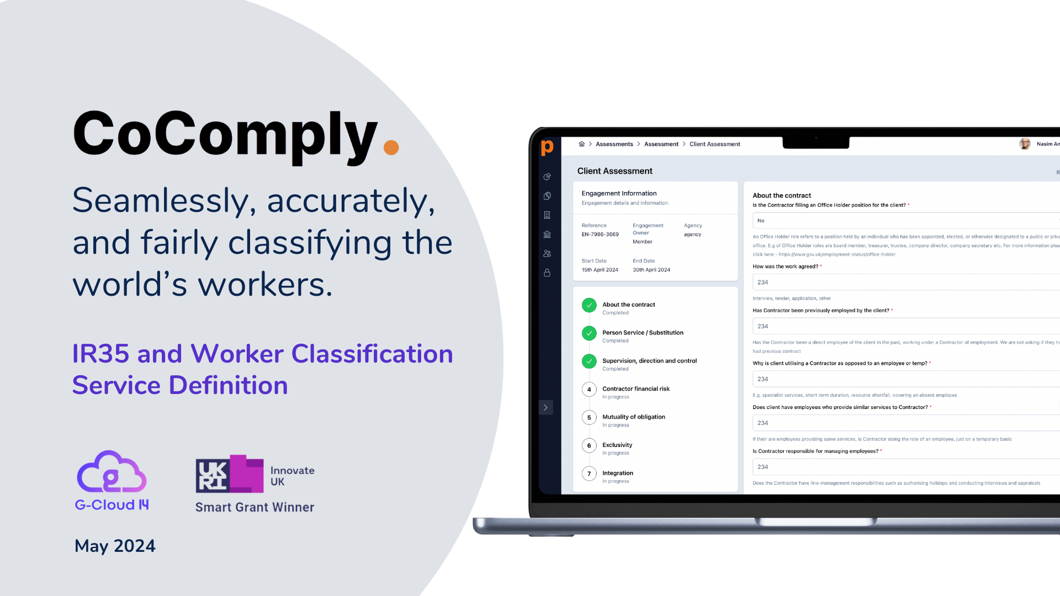

About CoComply
We comprehensively mitigate the risk and administrative burden of IR35 by running status determinations, contractual reviews and supply chain compliance, so clients can focus on their day job.

CoComply adapts to your processes and systems, without the need for you to adjust to ours.

CoComply's rapidly growing client base includes publicly-listed pharmaceutical and technology organisations, the world's largest gaming company, national sporting institutions, and renowned charities.

CoComply is unique…
In 2024, CoComply was recognised as one of the most innovative companies in both the UK and Europe, winning the prestigious UK government-funded Innovate UK award. CoComply is human-led and technology-agnostic powered by AI and ML to manage worker classification at scale.

In 2025, CoComply is anticipated to be one of the UK's fastest-growing companies.

IUK Smart Grant Winner 2024

Innovation Project Date: 1st April 2024 - 1st March 2025
CoComply was awarded the highly prestigious Innovate UK Smart Grant Award in April 2024. The IUK Smart Grant Award is a highly competitive process and is awarded to fewer than 2% of thousands of the UK's most innovative applicants. Significant Public funds are granted to organisations demonstrating innovative technological solutions to significant global business or public issues at scale.

Innovation - CoComply employs AI and LLMs to instantaneously analyse multiple data points, matching the precision of human legal experts, and delivering accurate classifications within seconds. Cutting-edge analytics enhance risk management, detail tax exposure, and cost savings and allow strategic data-based decisions to be made.

EDI - Commitment to diversity, promotion of women-in-tech; Offset CO2 emissions by x 275k annually; Support the fair and accurate classification of workers and ensuring organisations treat workers fairly and operate in a compliant manner

What opportunity does this present to customers and partners?
- Joint PR Opportunities
- Play a pivotal role in the development of advanced technical features that add value to your organisation
- Demonstrate unique innovation and significant business ROI to stakeholders and workers.

The IR35 and Worker Classification Problem
- Highly complex straddling multiple business functions
- Unsophisticated or manual solutions mean a choice between high-risk (off-payroll) or high-cost (on-payroll)
- Multi-jurisdictional requiring different approaches in different regions
- Frustrated contractors want fair and impartial classification, and the ability to work outside IR35 if they can and wish
- Digital forms can be easily manipulated. A lack of data means informed decisions cannot be made
- Class action from disgruntled workers who believe they have been misclassified
- Operational disruption and lengthy dispute periods
- Huge misclassification fines from regulators
- Reduced access to talented contractors

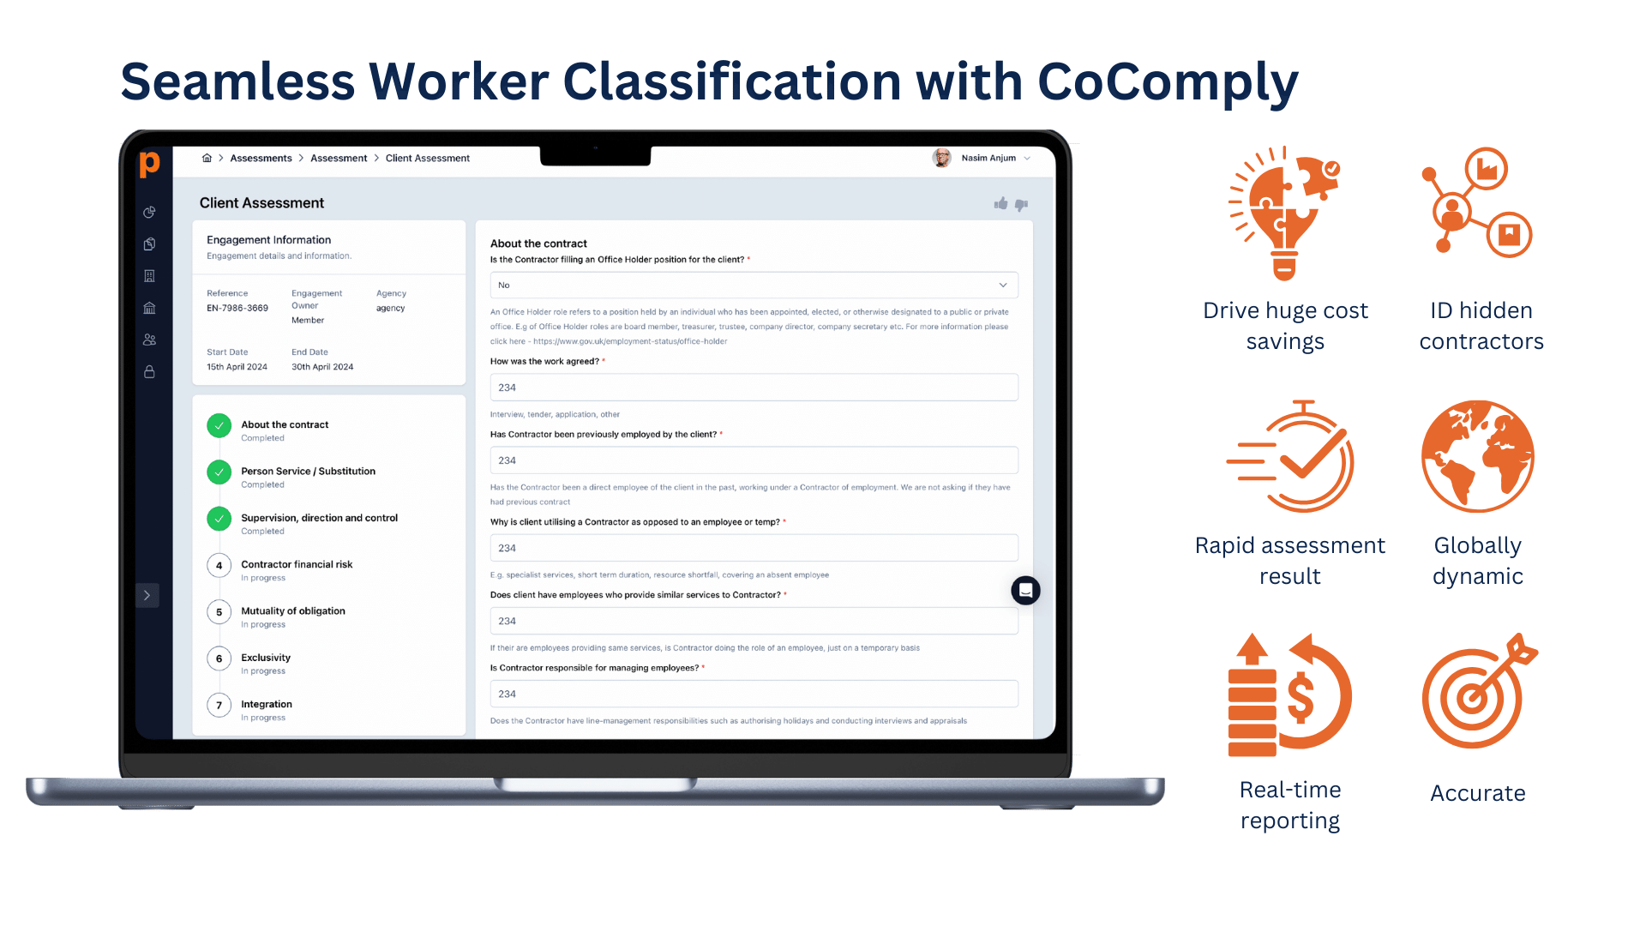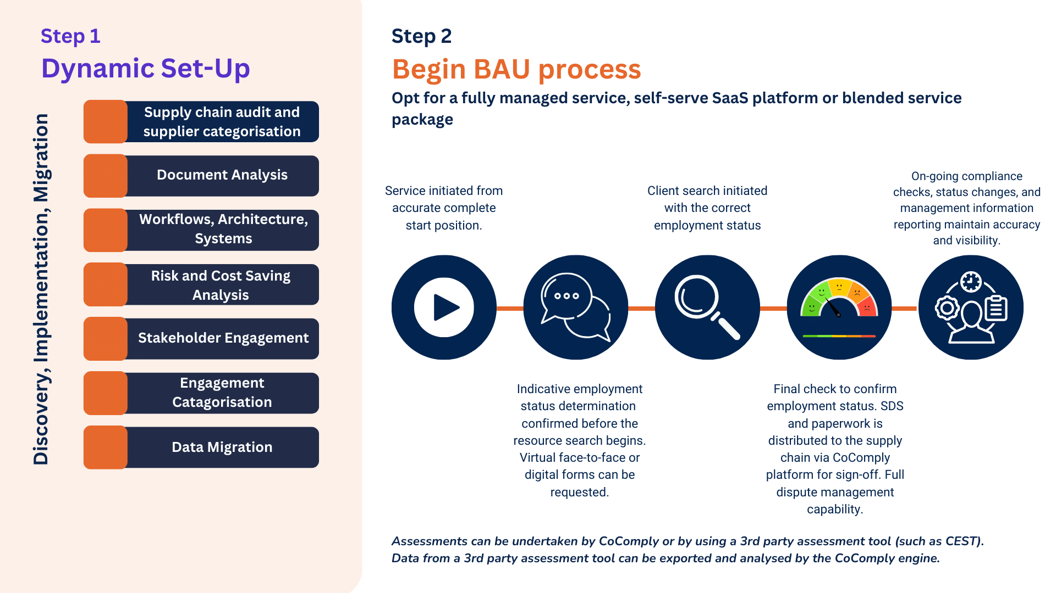

Seamless Worker Classification with CoComply
- Drive huge cost savings
- Rapid assessment result
- Identify hidden contractor populations
- Globally dynamic
- Accurate
- Real-time reporting

Exceptional On-Demand Service
- Client account managers have an SLA response time of 8 hours on technical compliance queries and typically respond in under 5 minutes for general queries.
- We support the re-engineering of roles where it is possible to do so compliantly, to support a ‘Self-Employed’ status
- We combine human expertise for quality service, with technology for scalability
- Weekly calls are scheduled to discuss any specific queries or questions clients may have.

Real-Life Examples - Case Study
CoComply was selected by a global pharma firm with 100 active contractors to manage IR35. All roles were assessed and categorised. Three roles, whilst originally assessed as inside IR35, could be restructured as ‘outside IR35’ due to the nature of the critical working practices of the engagements. CoComply worked with the stakeholders to make the necessary changes and to provide comprehensive training, guidance, and ongoing checks.
Transformation Lead
2 year contract
Day Rate: £895.00
Tax & Rate Saved: £131,052.95

Master Data Consultant
9 months
Day Rate: £500.00
Tax & Rate Saved: £73,213.94

Market Access Lead
2 year contract
Day Rate: £1000.00
Tax & Rate Saved: £146,427.88

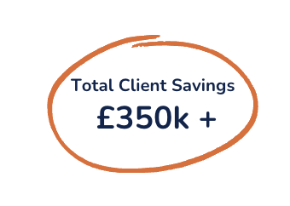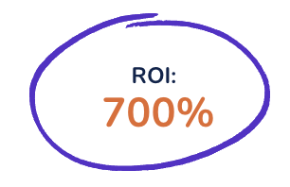

Accurate classify and analyse your contingent workforce

Features
- Customised, comprehensive IR35 assessment and worker classification, with AI/ML-enhanced legal technology and live in-platform human-led interaction.
- Efficient management for on-payroll and off-payroll workforce, suitable for PSCs, sole traders, and LLPs.
- Behavioural analytics and ongoing automated checks to maintain accurate IR35 status and prevent manipulation.
- Easy migration to and scalability on the CoComply platform, with options for self-serve CEST and third-party SDS repositories.
- Real-time, detailed reporting on contractors, statuses, costs, and risks, including supply chain audits to uncover hidden headcount.
- Features regular updates for cutting-edge functionality, tax risk management, and HMRC enquiry reporting.
- Strategic engagement restructuring for maximum compliance and cost savings.

Benefits
- Pinpoint worker classification accuracy at scale
- Total visibility of risk and compliance reporting
- Significant reduction in IR35 risk and non-compliance
- Compliantly engage specialist contractor talent
- Increased control and oversight over your off-payroll workforce
- Increased confidence of status assurance with advanced prevention of system and IR35 status manipulation

Case Study

Commvault
Commvault is an American publicly trading, data protection and data management software company, headquartered in Tinton Falls, New Jersey. Commvault enterprise software can be used for data backup and recovery, cloud and infrastructure management, retention and compliance.
They have 3000 employees globally, with a presence of around 250 employees in the UK.

What was the problem?
Commvault wanted a proactive partner - CEST is inadequate and insurance-backed tools do not prevent an investigation from being initiated, something which Commvault were keen to prevent due to the time investment required for any response or defence.
Commvault has a population of around 20 contractors providing a range of different service types, via agencies and directly into the business. The Commvault culture and policy is described as 'risk averse'.
In preparation for the April 2021 reforms, and to mitigate any risk of reputational damage, tax liability, or arduous investigations, Commvault needed a root and branch review of policy, process and current off-payroll status of each PSC and worker. The additional challenge was that some of the contractor suppliers were business-critical and unlikely to want to operate on an 'Inside IR35' basis.

What we did.
Commvault had a population of around 30 UK PSC contractors / workers providing a range of different service types:
- Direct to Commvault via procurement / direct to line managers
- Agency Off-Payroll
- Agency On-Payroll
- Third Party workers via strategic providers or micro-consultancies
CoComply assessed all governance, policy, contracts and processes Commvault had in place, with consideration paid to the Beeline HR system in situ. Process and policy were updated, adapted and communicated to all stakeholders, third party suppliers and workers.
Critically, where there were critical contractors providing services, CoComply worked closely with line managers to re-engineer the engagements to make them compliant with an off-payroll status. This involved creating compliant SoWs that are regularly managed
and re-assessed, as well as training for both contractors and line managers to ensure strong understanding of off-payroll working and compliance.

QUOTE
"CoComply are the go to. Any issues or queries, they are immediately on-hand, they understand our business and process having supported us in implementing policy and keep a tight grip on our compliance. It has saved us thousands and given us conﬁdence in engaging external workers"
Charlotte Dollery, HR Business Partner and Off-Payroll Lead

Results
- Commvault now has a seamless, robust IR35 and Worker Status working policy that is reportable and demonstrable to HMRC
- Re-engineered engagements, which would otherwise have been deemed 'on-payroll', has saved Commvault over £180,000 per year in unnecessary taxes HR has significantly reduced the feeling of exposure and conﬁdence in worker classiﬁcation that is reportable to board and public authority level.
- All workers and line managers have a signiﬁcantly increased awareness of the Off-Payroll working policy.
- Proactive queries and checks by stakeholders to CoComply increased from close to zero to 20+ per quarter, preventing missteps
- Commvault is working with CoComply to roll out the policy to other international jurisdictions, such as the US.

Contact

Michael Cleavely
Founder
michael@cocomply.co.uk
07830 163 267

Sarah Socha
Senior Partner Sales Manager
sarah.socha@cocomply.co.uk

Joe Johnson
Head of Delivery
joe.johnson@cocomply.co.uk

