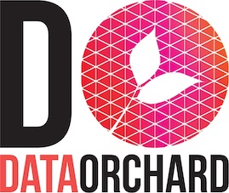

Skills for the
information age

Rate Card
G-Cloud 14
info@dataorchard.org.uk
May 2024

Standard Rate Card
Levels of responsibility | All categories
4. Enable | £600 - £720
5. Ensure / Advise | £770 - £940
6. Initiate / Influence | £990 - £1,100
7. Set Strategy / Inspire | £1,200 - £1,700

Standards for Consultancy Day Rate Cards
Consultant’s Working Day: 7.0 hours exclusive of travel and lunch
Working Week: Monday to Friday excluding national holidays
Office Hours: 09:00 – 17:00 Monday to Friday
Professional Indemnity Insurance: included in day rate
VAT: All Prices exclude VAT

