

GCloud 13

-

Service definition document: Content strategy and design

Prepared by: Alastair Lee, Director
Date: May, 2022

Contact: Alastair Lee - al@productpanda.com - 07748 807 143

Service Overview
When configuring cloud services to meet the needs of users in a specific context, service teams often need to generate substantial amounts of content (articles, FAQs, infographics, videos, interface copy) that combine to make the service valuable and usable.
If that content requires regular updating then there needs to be processes in place to ensure that is done effectively and efficiently.
If there is a large amount of content, then it needs to be made navigable though methods such as searching and browsing, thus necessitating consideration or information architecture and meta-data.
Our experienced consultants can advise on these matters and deliver content to meet requirements.

Activities
Our content strategy and design engagements typically involve some or all of these activities:

User research
Qualitative research with users to understand their goals and content needs.

Information architecture
Defining the structure of content in order to enable users to find what they are looking for.

Taxonomy and search
Defining and implementing meta-data schemas that enable dynamic clustering of content according to shared characteristics and also better use of internal search solutions.

Content creation
Producing content to meet user needs

Content planning
Defining processes for delivering and updating content in a timely manner in order to meet user needs.

Content testing
Creating testable content prototypes to gather feedback from users and staff.

Thank you
We hope you find this useful. Please visit thinkpanda.co.uk for more information.

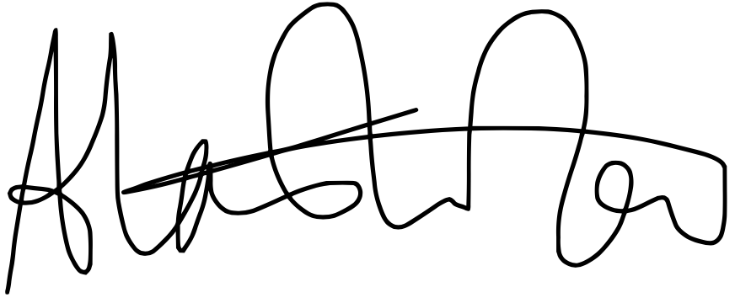

Alastair Lee
al@thinkpanda.co.uk
Tel: 07748 807 143

