

GCloud 13

-

Service definition document: Service Design

Prepared by: Alastair Lee, Director
Date: May, 2022

Contact: Alastair Lee - al@productpanda.com - 07748 807 143

Service Overview
Great services feel like they're on your side, helping you in ways you hadn't thought possible.
Designing great services means understanding users, organisations and what's technically possible - then weaving together people, processes and technology, to deliver that seamless and supportive experience.
We work collaboratively with service teams in sprints. Our engagements can range from 4 weeks to over a year.
We can focus on delivering service design activities ourselves and/or we can build the capability of internal service design teams. See this case study for an example of this in practice.

Activities
Our service design engagements typically involve some or all of these activities:

Setting goals and KPIs
We start by understanding what you want to achieve as an organisation and how we’ll measure progress.

Researching user needs
Mixed methods research to create a shared understanding of user (and staff) needs.

Experience mapping
Mapping existing journeys, identifying positives, painpoints and opportunities.

Technical assessment
Researching the technical environment to understand solution constraints.

Service blueprinting
Mapping a new system of interactions, people and processes to deliver an improved service.

Touchpoint design
Designing the specific digital and non-digital touchpoints that make up the service experience.

Prototyping
Creating testable prototypes to explore ideas and gather feedback from users and staff.

Usability testing
Testing experience design with users. Making sure the new envisaged service meets their needs.

Thank you
We hope you find this useful. Please visit thinkpanda.co.uk for more information.

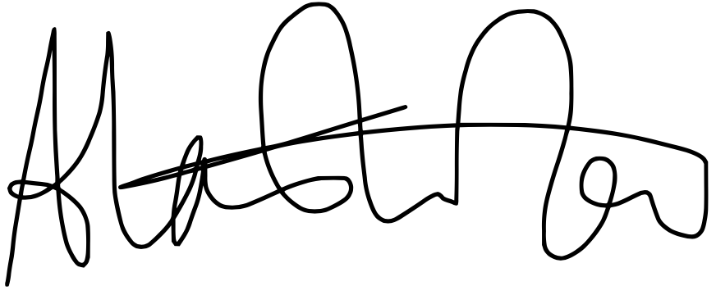

Alastair Lee
al@thinkpanda.co.uk
Tel: 07748 807 143

