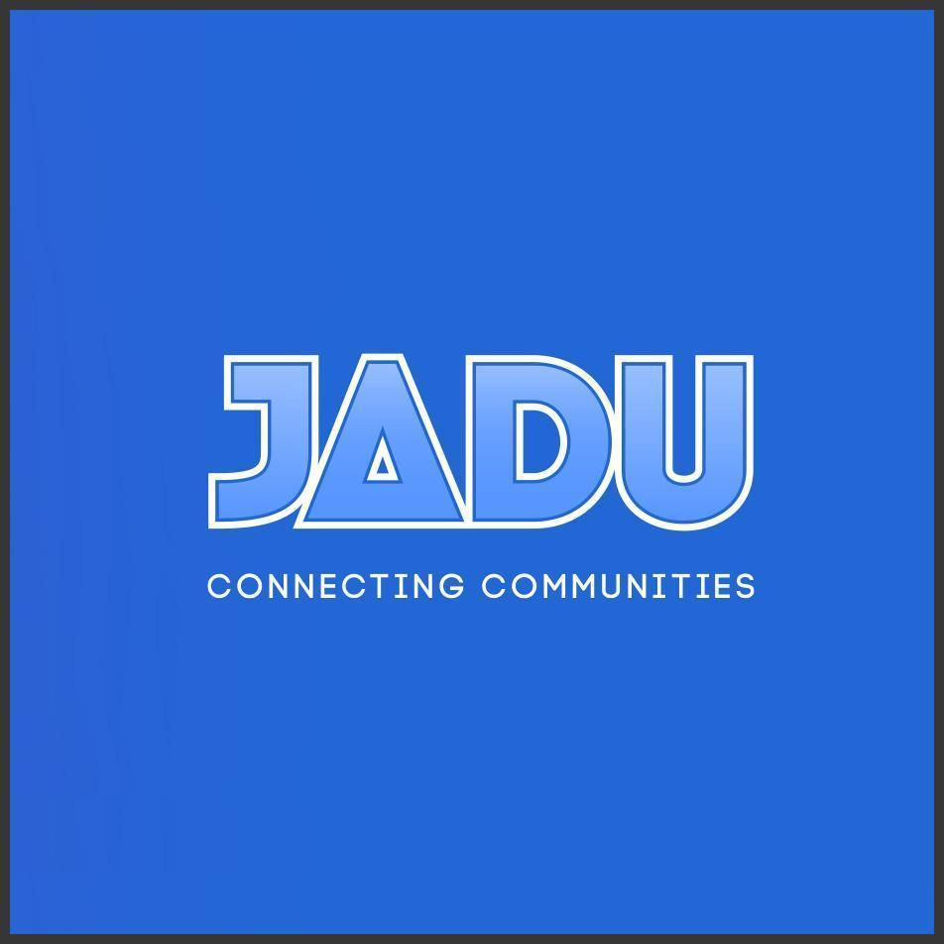

Cloud Support
Service Definition

Jadu Digital Services Training



Jadu is on a mission to become the world's most accessible digital platform.
Our documents are presented in an open format to ensure the content is accessible to everyone.

Jadu Digital Services Training

Service Description
Our Jadu Digital Services training blends training on the Jadu Digital Platform with the practical service design and consultancy skills required to create digital services that meet your users’ needs and maximise the value of your investment. Our tailored training combines digital and public-sector expertise designed to build your capability.

Features
- Blends Jadu accredited training, service design, consultancy and agile.
- Provides tailored training to align with organisational objectives.
- Uses case studies and real-world scenarios ensuring practical learning.
- Equips internal teams with essential practical digital skills.
- Collaborative approach fosters effective learning and knowledge sharing.
- Practical Jadu Digital Platform training for effective implementation
- Hands-on experience ensures proficiency in utilising Jadu Digital Platform.
- Training enables seamless design and build of digital services.
- Co-delivery facilitates applied learning and effective skills transfer.
- Learn how to leverage the Jadu Library and integrations.

Benefits
- Achieve self-sufficiency in digital service design and implementation.
- Blends Jadu training, service design, consultancy for comprehensive learning.
- Provides practical examples, hands-on advice for expert application.
- Builds in-house capability and confidence quickly with blended training.
- Reduce learning curve, gain deep understanding of Jadu Platform.
- Apply sector learning, enhance digital service design, streamline implementation.
- Practical advice, real-world examples enhance learning experience.
- Expert guidance and recommendations to maximise Jadu Digital Platform benefits.
- Learn to design better services, accelerate delivery, save resources.
- Utilise extensive digital service delivery experience for rapid learning.

About Jadu
Jadu helps organisations around the world build the best possible connections to their customers via our low-code, easy-to-use platform, and multi-award-winning design team

Our Team
Jadu was founded in 2001 by Suraj Kika, who today serves as Group Chief Executive Officer. He was soon joined by our Vice President of Engineering, Andy Perkins and Head of Brand and Film-maker, Lee Pilmore. Today, we’re a distributed team with people and customers all over the world.
It’s our mission to 'Provide the tools to organise information across the enterprise and make it accessible to humans and machines' and accessibility is sewn into the fabric of everything we do.
Jadu is now on a mission to become the World's most accessible digital platform.

The Way of Jadu
We believe that the tools we make should be beautiful, accessible to the highest quality and loved by the people that use them.
We are committed to our people, our culture and our values. "Conduct honest business" is our first directive. It's policy at Jadu to be honest about our business relationships - our customers are our partners, which means transparency and trust.
Our Jadu family is passionate about everything we do, we love to delight and amaze each other and our customers.

Some of our customers
Jadu is proud to help Local Government and Higher Education organisations all over the world to deliver outstanding digital experiences.


Working in partnership
At Jadu we work in partnership with our customers with a focus on collaboration, co-production and knowledge transfer. Our work is guided by our Prime Directives, representing our core values. We employ highly skilled teams and diverse delivery models, emphasising continuous learning and innovation in digital transformation. Our approach ensures effective partnerships, delivering tangible benefits to our clients.

Case Studies

Welwyn Hatfield Borough Council
“The impact the move to Jadu has had on delivering accessible digital services to our citizens has been second to none, and the internal process improvements have been even better than expected - what used to take five steps, now takes one.” Lucy Ellis, Website Development and Intranet Manager
Challenge
Welwyn Hatfield Borough Council’s technology stack was disjointed and the multiple systems it used weren’t connecting. This was costly, inefficient, and affected the citizens' digital experience. The council launched a new ‘Transformation Programme’ to rethink how it delivered digital self-service. In addition, Welwyn Hatfield committed to making its online services accessible to all and needed a solution that met web accessibility standards (WCAG 2.1). It needed to have the capability and flexibility to scale to enable a streamlined citizen web experience.
Solution
As part of its Transformation programme, Welwyn Hatfield chose Jadu Connect (Case Management) and Jadu Central (Website and Forms) solutions. The council chose ‘Helia’, one of Jadu’s Creative out-of-the-box themes which enabled an accessible website to be spun up, quickly and easily. The adaptability and flexibility of themes meant Welwyn Hatfield could choose to launch the theme as standard and add the council’s branding, colours, fonts, logos etc or add additional customised modules. The Helia theme they chose is an accessible by default (WCAG 2.1 AA compliant), service-focused design centred on delivering key information, and user-centred navigation to ensure citizens can find their way around the website quickly and easily
Result
Welwyn Hatfield Borough Council delivered its new website at speed whilst meeting accessibility WCAG 2.1 AA standards. The council moved up 181 places on the Sitemorse INDEX of UK local council websites. Cost savings were seen, as design and build costs were significantly reduced by selecting a Jadu Creative theme. Processes are now streamlined for both the employees and the citizens. Centralising systems, using low-code technology and providing a user-centred accessible design focused on navigation, has enabled citizens to access digital services quickly and effectively. The website is the council's busiest access channel and it has seen less contact coming via other channels, this reduces the amount of time employees are spending on manual tasks.
Full case study is available on our website: https://www.jadu.net/welwyn-hatfield-borough-council

Runnymede Borough Council
“More people want to report issues on their mobile phones and they expect the response from us to be digital. By moving to Jadu, citizens can access important services from anywhere at any time and keep track of their cases online.” Linda Norman, Head of Customer, Digital & Collection Services.
Challenge
Runnymede Borough Council realised that its existing technology could not meet the expectations of its citizens. Insufficient investment led to duplicative processes, sluggish response times, and declining customer service standards. The Covid-19 pandemic heightened the demand for online access to local authority services. Linda Norman, Corporate Head of Customer, Digital & Collection Services, took responsibility for addressing these challenges as part of an overarching strategy to enhance customer services and technological efficiency. The goal was to “make every contact count” ensuring seamless user experience online. Tasked with achieving £250,000 in annual savings and major customer service improvements, the Runnymede Digital team led the transformation effort.
Solution
To enhance customer services and reduce costs, Linda Norman utilised a visual strategy, presenting a future vision through a postcard. This kickstarted a technology refresh, upgrading hardware and implementing updated Microsoft and NEC applications (formerly known as Northgate Services). This modernisation replaced legacy systems, improving user experience for the staff. With core technologies updated, the focus shifted to enhancing the citizen experience. Runnymede Borough Council selected the Jadu Digital Platform, which included Jadu Central 2.0 (Content Management System and Forms) and Jadu Connect (Case Management) in November 2020, and completed implementation within 10 months, creating a fully integrated digital platform. This integration process, managed in-house by a small team, ensured seamless integration with existing technologies. Notably, Jadu provided Runnymede with control over website content management for the first time, after they had previously shared a content management system with a neighbouring local authority. Having control of its web content management has led to Runnymede delivering excellent digital accessibility. Independent digital accessibility experts Silktide has ranked Runnymede as the joint first position in accessibility for 13 consecutive months in its Accessibility Index for UK Local Authorities.
Result
Today, Runnymede Borough Council is meeting the digital expectations of its citizens. In just 10 months, the local authority systems and processes have gone from outdated systems and processes to a new website, the launch of OneAccount, payments and customer service platforms. These technological advancements have led to significant financial gains, savings, and enhanced customer service. The Jadu Digital Platform has delivered £14 million in revenue for the council since August 2021. For example, the garden waste bin services witnessed over 80% of subscribers renewing online with direct debit payments, streamlining the process and eliminating complexities. The implementation of a reporting hub using Jadu Connect and open-source technology has resulted in £190,000 in cost avoidance, benefiting various business processes across the local authority. These savings have been reinvested to further improve services, ensuring budget stability.
Full case study is available on our website: https://www.jadu.net/homepage/232/runnymede-borough-council

Accreditations
Jadu is accredited with ISO 27001 for information security and has a robust organisation-wide Information Security Management System. The ISO 27001 accreditation is subject to continuous review and a programme of both internal and external audits to ensure on-going compliance.
Jadu also has Cyber Essentials accreditation which is audited annually which includes our hosting service delivery within the defined scope of this certification.
Jadu is also accredited to ISO 9001 in terms of quality management.
Jadu is always looking to improve adherence to other security standards / certifications and as such standards evolve, so please contact us if any of the standards you are looking for are not mentioned in this listing and we will be able to confirm details with you.

Social Value
Jadu is dedicated to giving back to the community, including involvement in environmental initiatives, promoting team wellbeing and supporting local and global charities.
You can find some of our most recent activities below:
Initiative | Description
Supporting those in need | For Christmas 2023, we sent a donation to FareShare UK. This was to deliver approximately 28 meals per Jadu team member to help feed vulnerable people and those who need a meal the most during the holiday season. In total, it was approximately 2,240 meals that went out to communities!  We regularly sponsor our team and our customers in fundraising efforts for charities.
Digital inclusion | We're pleased to have sponsored the Deque Systems Axecon event this year as Community Sponsors.  Axe-con is the world’s largest digital accessibility conference that welcomes developers, designers, business users, and accessibility professionals of all experience levels to an accessibility conference focused on building, testing, and maintaining accessible digital experiences.  As a Community Sponsor, we made a donation that was equally split between to Black Girls Code, NV Access Limited and the Disability Visibility Project.
Mental Health & Wellbeing | The mental health and wellbeing of our team is of paramount importance to us.  We've invested in Mental Health First Aid Training for some of our team members to be on hand should someone need support. We also provide the option for our team, when needed, to receive therapy from Wellbeing Therapy Solutions. We have previously and will continue to support Mind Mental Health Charity.
Fighting Cancer | At Jadu, cancer is a subject very close to our hearts, and it's probably very close to yours too. 1 in 2 people are expected to get the diagnosis during their lifetime. Those odds are far too high.  From November 2021 to March 2023, the Jadu team undertook different tasks and activities to help raise funds for Cancer Research UK, including running a tough mudder and rowing one million miles, to name a few activities. We are committed to continuing our efforts to support cancer charities all over the world.

Our List of G-Cloud Services

Lot Number | Listing
Lot 1 – Cloud Hosting | Cloud Hosting
Lot 2 – Cloud Software | Jadu Digital Platform
Lot 2 – Cloud Software | Jadu Digital Platform Lite
Lot 2 – Cloud Software | Jadu Central
Lot 2 – Cloud Software | Lot 2 Jadu Central Lite
Lot 2 – Cloud Software | Lot 2 Digital Platform by Jadu (Renewals)
Lot 3 – Cloud Support | Jadu Health Check
Lot 3 – Cloud Support | Jadu Innovation & Solution Design
Lot 3 – Cloud Support | Jadu Discovery, Prioritisation & Planning
Lot 3 – Cloud Support | Jadu Digital Service Design & Delivery
Lot 3 – Cloud Support | Jadu Digital Services Training
Lot 3 – Cloud Support | Jadu Digital Platform Acceleration Services
Lot 3 – Cloud Support | Jadu Sprint Zero
Lot 3 – Cloud Support | Data Analytics and Business Intelligence
Lot 3 – Cloud Support | IT Governance and Compliance
Lot 3 – Cloud Support | Change Management and Training
Lot 3 – Cloud Support | CRM Strategy and Implementation
Lot 3 – Cloud Support | Digital Transformation Consulting
Lot 3 – Cloud Support | Innovation Workshops and Ideation Session
Lot 3 – Cloud Support | Process Automation and Efficiency
Lot 3 – Cloud Support | Service Design
Lot 3 – Cloud Support | Technology Road mapping and Advisory
Lot 3 – Cloud Support | Digital, Data and Technology Services Review
Lot 3 – Cloud Support | Digital Service Improvement Review
Lot 3 – Cloud Support | Digital Transformation Discovery and Roadmap
Lot 3 – Cloud Support | Digital Strategy and Roadmap
Lot 3 – Cloud Support | Digital Operating Model and Roadmap
Lot 3 – Cloud Support | Digital Applications Rationalisation
Lot 3 – Cloud Support | Digital Architecture and Roadmap
Lot 3 – Cloud Support | Digital Transformation Training
Lot 3 – Cloud Support | Digital Services Design and Delivery
Lot 3 – Cloud Support | Digital Strategy Evaluation
Lot 3 – Cloud Support | Digital Transformation Assessment
Lot 3 – Cloud Support | Digital Maturity Assessment
Lot 3 – Cloud Support | Jadu Digital Platform Central and Galaxies Themes
Lot 3 – Cloud Support | Jadu Digital Platform Creative Design Services
Lot 3 – Cloud Support | Jadu Digital Platform Custom Software Development Services
Lot 3 – Cloud Support | Jadu Digital Platform Custom Software Development Services - Rapid Scoping Workshop
Lot 3 – Cloud Support | Jadu Digital Platform - Integration Services
Lot 3 – Cloud Support | Jadu Digital Platform Integration Services - Rapid Scoping Service
Lot 3 – Cloud Support | Jadu Content Design Services
Lot 3 – Cloud Support | Jadu Digital Platform Training
Lot 3 – Cloud Support | Jadu Digital Platform Professional Developer Service Bundle
Lot 3 – Cloud Support | Jadu Accessibility Services
Lot 3 – Cloud Support | Jadu Accessibility Audits
Lot 3 – Cloud Support | Cloud Support & Platform Management (existing licence holders)
Lot 3 – Cloud Support | Project & Programme Management
Lot 3 – Cloud Support | Jadu Digital Professional Services

How to Obtain Further Information
For further information, please refer to our website www.jadu.net, email us at info@jadu.net or contact us on 0116 222 7242.



Jadu Starbase
Dock 2204
75 Exploration Drive
Space City, Leicester, LE4 5NU
Telephone: 0116 222 7242
Email: sales@jadu.net
Website: www.jadu.net

